**Implementing the first two epochs of a Isoline Algorithm**



# Algorithm Flowchart

See below flowchart in Figure 1, of how the Isoline algorithm could be implemented to draw Isolines onto a data matrix. 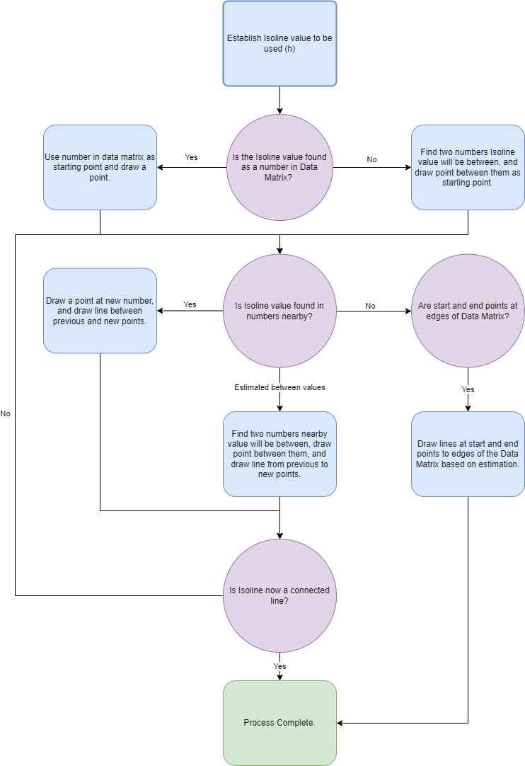

Figure - Flowchart Diagram of Isoline Algorithm.

# Epoch One

Using the table provided in **Appendix One**, two epochs or iterations will be conductedto draw isolines where h = 11, using the algorithm shown in Figure 1.

## Epoch One

From the initial point, there is no value that holds 11 (h = 11). therefore, will need to find two numbers that between them would hold the value of 11, and for any subsequent points going forward. See table one to show how the isoline was created for Epoch One with relevant steps taken.

Table - Steps taken to draw isoline for Epoch One

|  |  |  |
| --- | --- | --- |
| Step | Number range 1 | Number range 2 |
| 1 | 13 | 10 |
| 2 | 10 | 17 |
| 3 | 16 | 9 |
| 4 | 17 | 10 |
| 5 | 10 | 13 |
| 6 | 13 | 8 |
| 7 | 8 | 13 |
| 8 | 13 | 10 |
| 9 | 10 | 17 |
| 10 | 9 | 16 |
| 11 | 10 | 17 |
| 12 | 10 | 13 |
| 13 | 8 | 13 |
| 14 | 8 | 13 |
| 15 | 10 | 13 |
| 16 | 10 | 17 |
| 17 | 9 | 16 |
| 18 | 10 | 17 |
| 19 | 13 | 10 |
| 20 | 8 | 13 |
| 21 | 13 | 8 |
| 21 | 10 | 13 |
| 22 | 17 | 10 |
| 23 | 16 | 9 |
| 24 | 17 | 10 |
| 25 | 13 | 10 |
| 26 | 13 | 8 |
| 27 | 13 | 8 |
| 1 | 13 | 10 |

Finally, see attached visual representation of Isoline drawn for Epoch One in Figure 2.

Figure - Isoline create for Epoch One

# Appendix One – Table for Isoline Creation

|  |  |  |  |  |  |  |  |  |  |  |  |  |  |  |  |  |  |  |  |  |
| --- | --- | --- | --- | --- | --- | --- | --- | --- | --- | --- | --- | --- | --- | --- | --- | --- | --- | --- | --- | --- |
| 162 | 145 | 130 | 117 | 106 | 97 | 90 | 85 | 82 | 81 | 82 | 85 | 90 | 97 | 106 | 117 | 130 | 145 | 162 | 181 | 200 |
| 145 | 128 | 113 | 100 | 89 | 80 | 73 | 68 | 65 | 64 | 65 | 68 | 73 | 80 | 89 | 100 | 113 | 128 | 145 | 164 | 185 |
| 130 | 113 | 98 | 85 | 74 | 65 | 58 | 53 | 50 | 49 | 50 | 53 | 58 | 65 | 74 | 85 | 98 | 113 | 130 | 149 | 170 |
| 117 | 100 | 85 | 72 | 61 | 52 | 45 | 40 | 37 | 36 | 37 | 40 | 45 | 52 | 61 | 72 | 85 | 100 | 117 | 136 | 157 |
| 106 | 89 | 74 | 61 | 50 | 41 | 34 | 29 | 26 | 25 | 26 | 29 | 34 | 41 | 50 | 61 | 74 | 89 | 106 | 125 | 146 |
| 97 | 80 | 65 | 52 | 41 | 32 | 25 | 20 | 17 | 16 | 17 | 20 | 25 | 32 | 41 | 52 | 65 | 80 | 97 | 116 | 137 |
| 90 | 73 | 58 | 45 | 34 | 25 | 18 | 13 | 10 | 9 | 10 | 13 | 18 | 25 | 34 | 45 | 58 | 73 | 90 | 109 | 130 |
| 85 | 68 | 53 | 40 | 29 | 20 | 13 | 8 | 5 | 4 | 5 | 8 | 13 | 20 | 29 | 40 | 53 | 68 | 85 | 104 | 125 |
| 82 | 65 | 50 | 37 | 26 | 17 | 10 | 5 | 2 | 1 | 2 | 5 | 10 | 17 | 26 | 37 | 50 | 65 | 82 | 101 | 122 |
| 81 | 64 | 49 | 36 | 25 | 16 | 9 | 4 | 1 | 0 | 1 | 4 | 9 | 16 | 25 | 36 | 49 | 64 | 81 | 100 | 121 |
| 82 | 65 | 50 | 37 | 26 | 17 | 10 | 5 | 2 | 1 | 2 | 5 | 10 | 17 | 26 | 37 | 50 | 65 | 82 | 101 | 122 |
| 85 | 68 | 53 | 40 | 29 | 20 | 13 | 8 | 5 | 4 | 5 | 8 | 13 | 20 | 29 | 40 | 53 | 68 | 85 | 104 | 125 |
| 90 | 73 | 58 | 45 | 34 | 25 | 18 | 13 | 10 | 9 | 10 | 13 | 18 | 25 | 34 | 45 | 58 | 73 | 90 | 109 | 130 |
| 97 | 80 | 65 | 52 | 41 | 32 | 25 | 20 | 17 | 16 | 17 | 20 | 25 | 32 | 41 | 52 | 65 | 80 | 97 | 116 | 137 |
| 106 | 89 | 74 | 61 | 50 | 41 | 34 | 29 | 26 | 25 | 26 | 29 | 34 | 41 | 50 | 61 | 74 | 89 | 106 | 125 | 146 |
| 117 | 100 | 85 | 72 | 61 | 52 | 45 | 40 | 37 | 36 | 37 | 40 | 45 | 52 | 61 | 72 | 85 | 100 | 117 | 136 | 157 |
| 130 | 113 | 98 | 85 | 74 | 65 | 58 | 53 | 50 | 49 | 50 | 53 | 58 | 65 | 74 | 85 | 98 | 113 | 130 | 149 | 170 |
| 145 | 128 | 113 | 100 | 89 | 80 | 73 | 68 | 65 | 64 | 65 | 68 | 73 | 80 | 89 | 100 | 113 | 128 | 145 | 164 | 185 |
| 162 | 145 | 130 | 117 | 106 | 97 | 90 | 85 | 82 | 81 | 82 | 85 | 90 | 97 | 106 | 117 | 130 | 145 | 162 | 181 | 200 |